Ve370 Introduction to Computer Organization
Homework 1

- Exercise 1.3.1 ~ 1.3.3
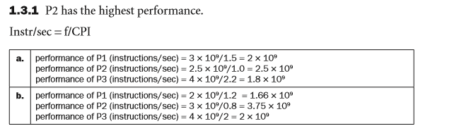
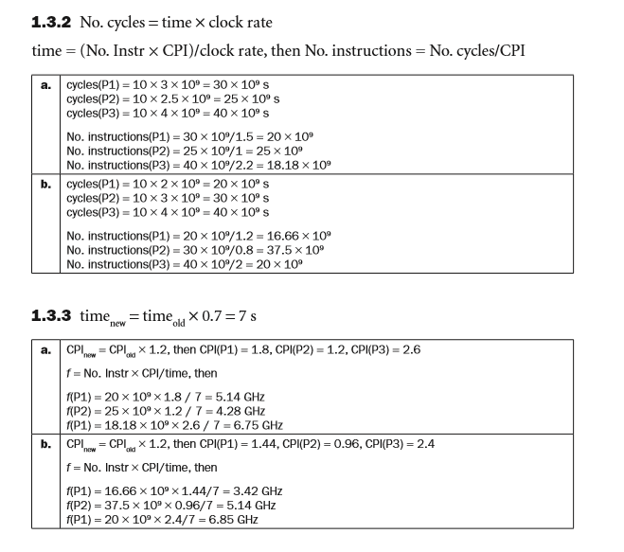
- Exercise 1.4.4 ~ 1.4.6
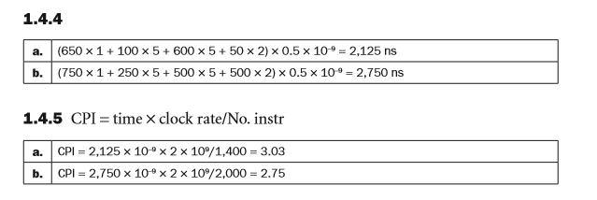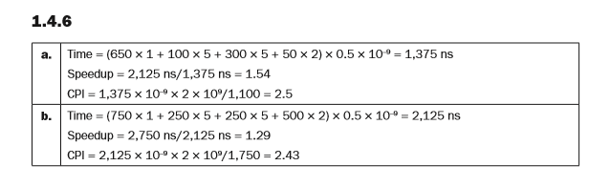
- Exercise 1.10.1 ~ 1.10.5
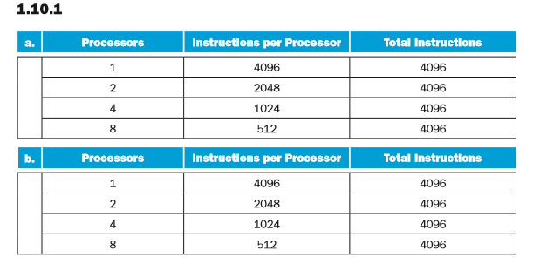
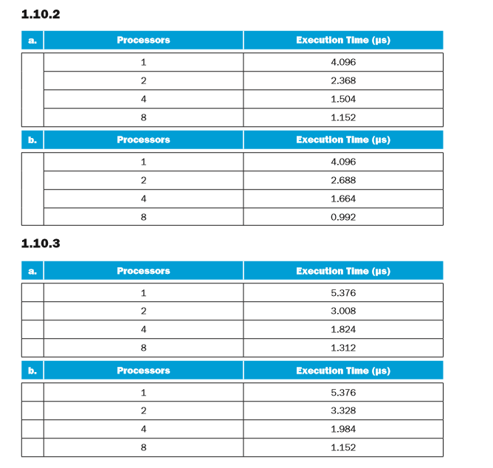
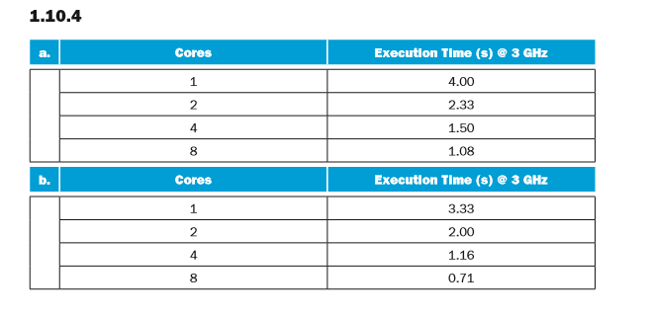
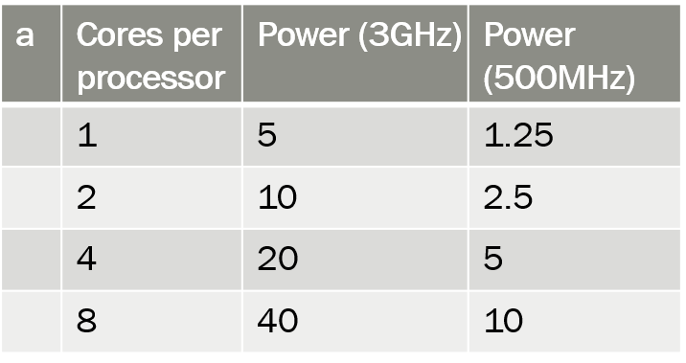
And the same answer for b
- Exercise 2.3.1
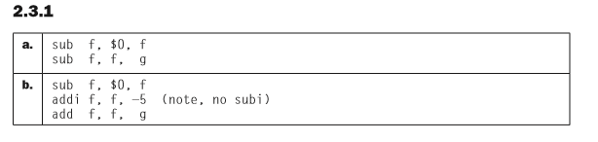
- Exercise 2.6.1
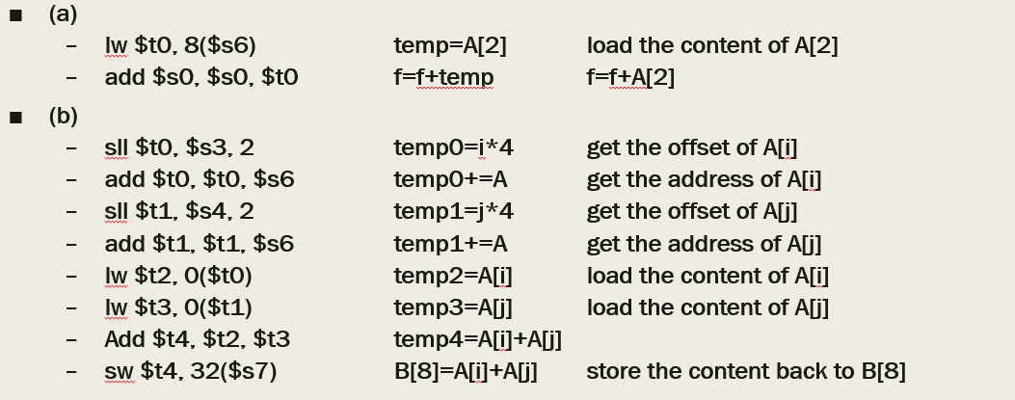
- Exercise 2.6.4
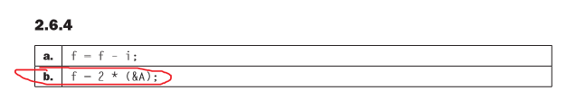
- Exercise
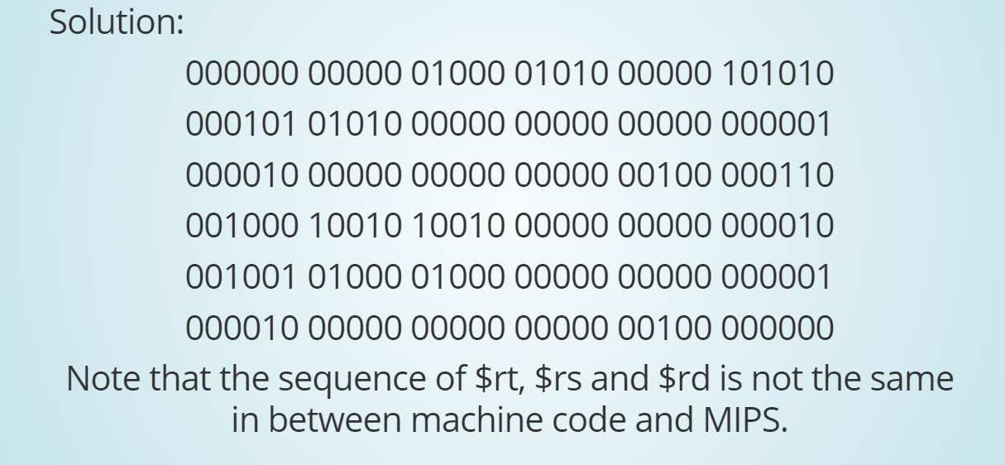
- Exercise
lui $t0, 4096
lb $s1, 2($t0)

$s1: 0x00000089
- Exercise 2.19.1 (15 points)

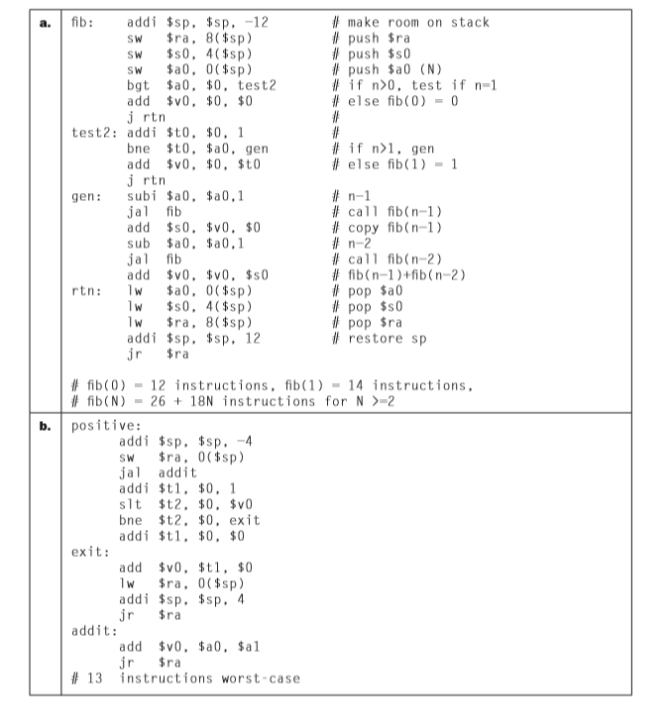
- Exercise 2.19.2 (10 points)
- Exercise 2.19.3 (10 points)
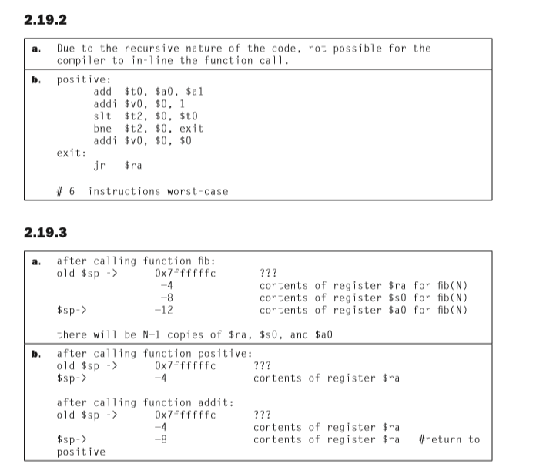
- Exercise 2.23.1
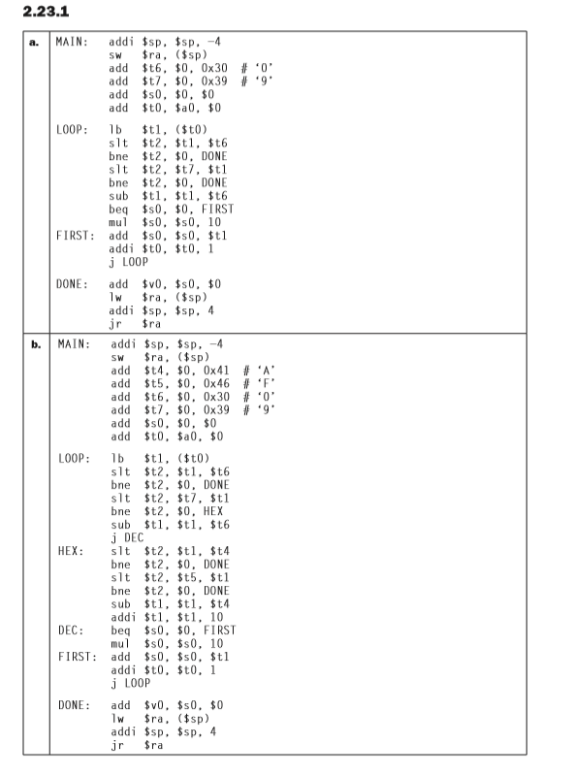
- Exercise 2.24.3
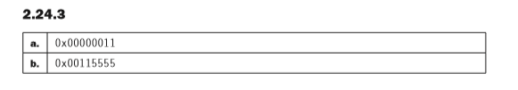
- Exercise 2.26.1
- Exercise 2.26.2
